GitHub Link - <https://github.com/VCCT-PROG6212-2025-G1/ST10273397_PROG6212_POE>

Programming 2b: Portfolio of Evidence

Nicholas Wolfaardt – ST10273397

Table of Contents

Project Plan 3

UML Class Diagram 4

Database Structure 4

GUI Design 5

Overall Layout and Structure 5

Header (Navigation Bar) 5

Main Content Area 5

Footer 5

Colour, Typography and Branding 5

Typography 5

Colour Coding 6

Form Design and Interactivity 6

Login Page 6

Claim Submission 6

Data Presentation and Tables 6

Tables 6

Dynamic Data Rendering 7

Responsiveness and Accessibility 7

Responsiveness Design 7

Accessibility Considerations 7

Interaction and User Feedback 7

Subtle Animations 7

Action Confirmations 7

Realt-time Validation Feedback 7

Summary 8

User Experience and Functional Clarity 8

References 9

Disclosure of AI Usage in my Assessment 9

Screenshots 10

# Project Plan

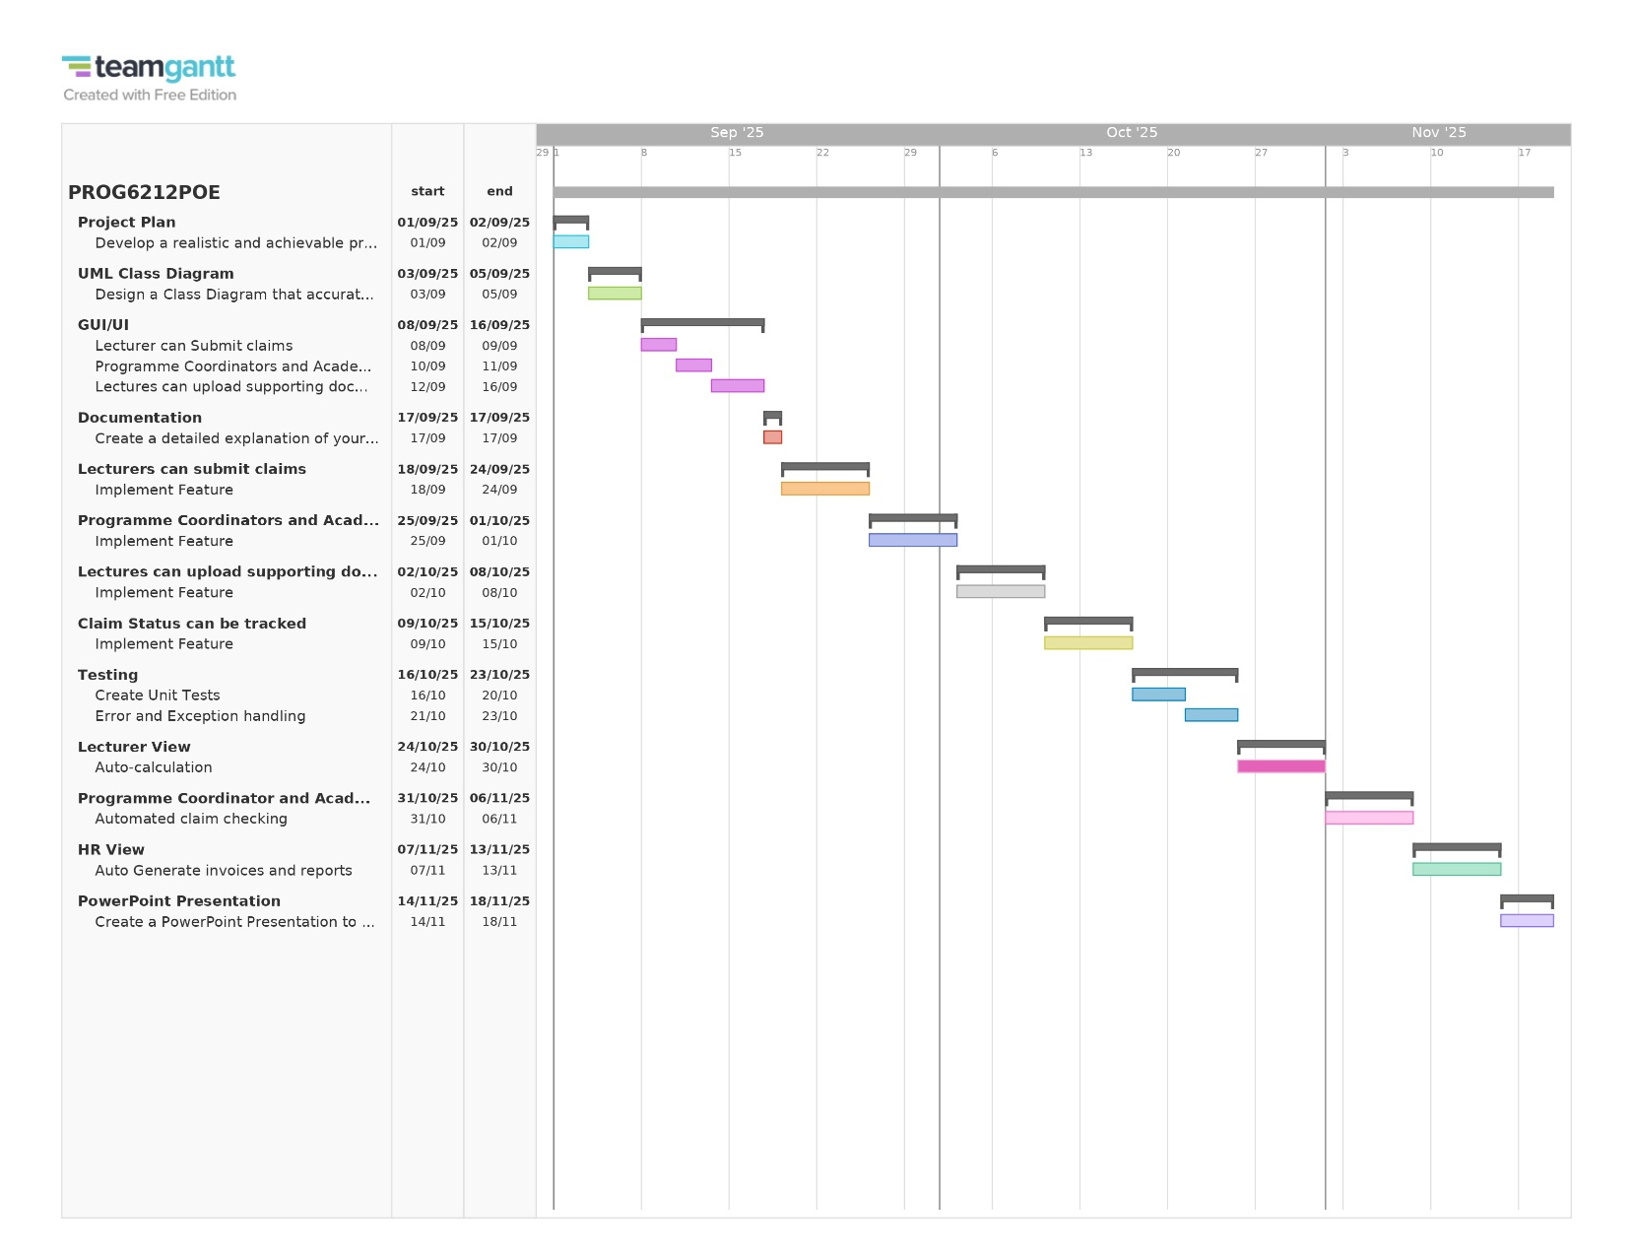

Figure 1: Made With TeamGantt (TeamGantt, 2025)

# UML Class Diagram

Figure 2: Made with Draw.io

## Database Structure

Lecturers can submit many claims but only a claim can only be submitted by one lecturer. Then the claim can be Approved/Verified by either one Programme Coordinate or one Academic Manager. Lecturer’s simply log in with their email and can submit a claim by filling in the title, what they specifically did, and the amount, and any supporting documents that are needed. The Programme Coordinater’s and Academic Manager’s will give a claim it’s status after reviewing what claims have been submitted by what lecturers. The Lecturers can see the progress of their claims.

# GUI Design

## Overall Layout and Structure

### Header (Navigation Bar)

Sticky-top is used to position the header at the top, guaranteeing continuous access to navigation controls and increasing work efficiency. In accordance with standard user interface patterns, the logout option is clearly shown on the far right, while the brand identification ("Lecturer Claim Approval") is combined with an icon for instant recognition. To guarantee responsive adaption, the navbar makes use of navbar-expand-lg, and a toggle button is provided for mobile users.

### Main Content Area

To provide uniform spacing and alignment, the primary content is positioned inside a flexible, centred container (container, py-4). Card-based design (card shadow-lg rounded-3) is used on pages to enhance focus and visually contain content. Furthermore, without overpowering the user, delicate fade-in animations (fadeIn) improve the impression of fluid interactions and modernity.

### Footer

The copyright and privacy links in the bottom remain consistent throughout all pages. It reinforces branding and offers visual feedback through its colour and hover states (text-white, hover: #ffd166). A full-height flex layout is supported by using mt-auto, which guarantees that the footer stays at the bottom of the viewport.

## Colour, Typography and Branding

### Typography

To improve hierarchy, titles and headings employ fw-bold and modified font sizes. To minimise visual noise, secondary information is shown with letter spacing enabled and text quiet. The navbar-brand strengthens brand identity and adds a touch of refinement.

### Colour Coding

For readability, the primary blue (#0d6efd) is used regularly on buttons, headers, and navigation to create a strong contrast with the light background (bg-light). In order to offer instant visual indications regarding claim status, status badges are colour-coded (Rejected = red, Approved = green, and Pending = yellow). Interactive elements with hover effects promote exploration and offer relevant feedback.

## Form Design and Interactivity

### Login Page

To direct user attention, login forms are centrally aligned (vh-100 d-flex justify-content-center align-items-center). To add clarity, input fields are accompanied with placeholders and labels. The form provides instantaneous, context-specific feedback by utilising novalidate with Bootstrap client-side validation. By limiting input to specific roles, the role selection dropdown minimises errors.

### Claim Submission

The title, amount, and document upload elements are properly grouped together in claim submission forms. Users can attach files to provide supporting documentation, and action buttons (Back for outline, Submit for primary) are clearly marked to help users make informed judgements. For a strong, intuitive experience, the form also includes validation feedback.

## Data Presentation and Tables

### Tables

Table-striped and table-hover enhance readability, and tables are made to be responsive and data-centric. Visual homogeneity is ensured by column alignment (align-middle, text-center), and file kinds are quickly indicated by icons. To cut down on errors and increase workflow efficiency, the action buttons for review tables (Approve, Reject) are grouped and plainly styled.

### Dynamic Data Rendering

Scalability and real-time updates are made possible via server-side data rendering (@foreach (var item in Model)). Badges that are conditionally formatted according to claim status provide for instant visual difference and facilitate rapid scanning and decision-making.

## Responsiveness and Accessibility

### Responsiveness Design

The responsive tools and grid of Bootstrap guarantee that the portal maintains usability while adjusting fluidly to various screen sizes and devices.

### Accessibility Considerations

Accessibility standards are supported with high contrast elements, unambiguous labelling, and hover/focus feedback for interactive elements. Inline validation messages from forms improve understanding for users with a range of needs.

## Interaction and User Feedback

### Subtle Animations

Hover transitions and fade-in effects add a contemporary vibe and improve user engagement without detracting from the main features.

### Action Confirmations

In accordance with safe interaction design principles, buttons for approval and rejection trigger confirmation dialogues to stop unintentional actions.

### Realt-time Validation Feedback

By directing users to fix input problems right away, inline notifications (invalid-feedback) increase form submission accuracy and lessen user annoyance.

## Summary

### User Experience and Functional Clarity

The portal successfully combines usability, domain-specific functionality, and visual hierarchy. Academic managers, program organisers, and lecturers may complete tasks more quickly thanks to colour coding, typography, responsive style, and interactive feedback. The design demonstrates a careful comprehension of both the particular workflow requirements for submitting and reviewing claims as well as UX concepts.

# References

OpenAI. 2024. Chat-GPT (Version 3.5). [Large language model]. Available at: [https://chat.openai.com/](https://chat.openai.com/%20) [Accessed: 17 September 2025].

TeamGantt. (2025). *TeamGantt*. Retrieved May 8, 2025, from https://www.teamgantt.com/ [Accessed: 17 September 25]

Troelsen, A. and Japikse, P. 2021. Pro C# 9 with .NET 5: Foundational Principles and Practices in Programming. 10th ed. Apress.

# Disclosure of AI Usage in my Assessment

* AI was only used during the GUI portion of the assignment.
* Only ChatGPT by OpenAI was used.
* The purpose was to help create a better looking and stylized GUI as the GUI I created was very dull.
* AI was used on the 17th of September 2025.09.17
* <https://chatgpt.com/share/68cb0b82-e938-8012-871f-bd5c46beb412>

## Screenshots

